An Overview of Voyant Subscription Groups (SubGroups)

2017-08-13
2018-07-31

An Overview of Voyant Subscription Groups (SubGroups)
Voyant originally provided a fixed 3-layer hierarchy to govern permissions to view and perform actions on users, clients, and analytics records in the Voyant system.
Beyond every user’s capability to perform actions on objects at the individual user level, certain users may be assigned roles to perform actions at the system-wide level, entity group level, or subscription level.
The most canonical example of this is client record access. In general, a user may access client records that they have created or been granted direct access. Additionally, certain users in management, administrative, or support, roles may be given a role such as Subscription All Client Access. With this role, a user is granted access to every client assigned to the subscription where the user is a member. The same applies at the higher levels for entity groups, using the Entity group-wise All Client Access role, and at the system with the role System-wide All Client Access.
Similarly, roles exist for user access, analytics reports viewing, and other items in the system.
Key Properties of 3-tiered System
- Every user in the system is a member 1 subscription (in turn every subscription is a member of 1 entity group).
- A client record is attached to 1 subscription - Any number of users from any subscription in the system may be designated with direct access to a client record, but the client record has a single attached subscription
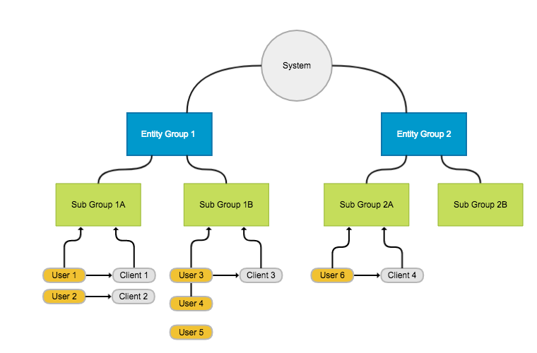
Figure 1: Current 3-layer structure: system, entity groups, and subscriptions

Providing Unlimited Layers: Subscription Groups
To create a more flexible structure that matches more closely the hierarchal structure of large organizations, an “unlimited” group layer below the subscription layer (called Subscription Groups) is added. All existing functionality that works on the system, entity group, or subscription level, is modified to provide a group level function.
The key enhancement provided by the group layer is the infinite nesting of groups within groups. This nesting allows organizations to mimic their internal multi-layer hierarchies within the Voyant Entity Group, Subscription, and new Group layers.
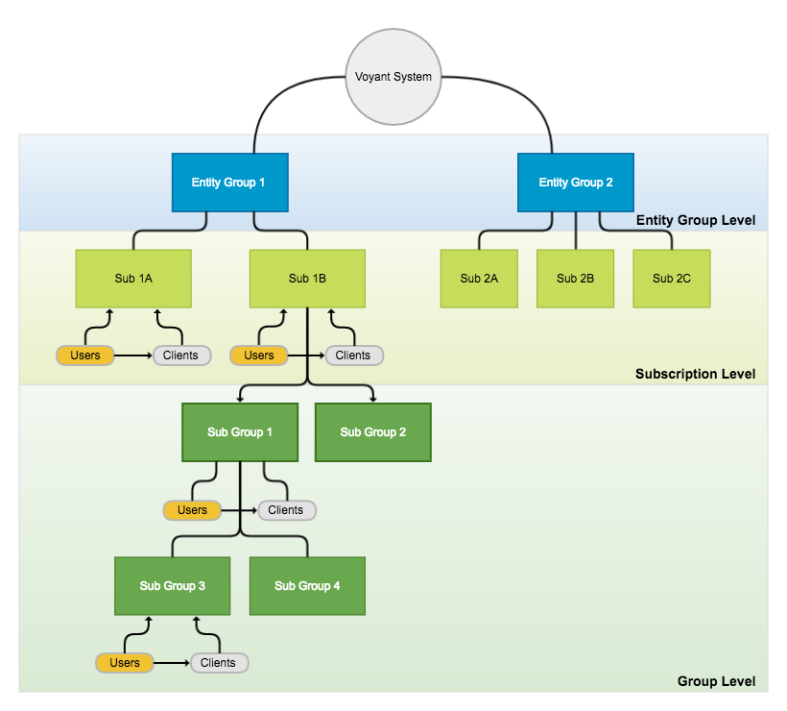
Figure 2: Subscription Group Level added to Voyant En tity Groups and Subscriptions
Key Properties of Subscription Groups
- All key properties of the 3-tiered system above still apply
- A subscription group is a member of 1 subscription.
- A subscription group may have 1 parent subscription group or no parent. If the subscription group has no parent group, then it is considered a direct child of the subscription.
- A subscription group may be the parent group of an unlimited number of other subscription groups, meaning any group has an unlimited number of direct child groups.
- A user may be a direct member of 1 subscription group. This group must be in the subscription the user is a member of. If the user is not a direct member of a subscription group, then it sits at the subscription level.
- A client record may be attached to 1 subscription group. If not attached to a subscription group, the client is considered attached at the subscription level.
- A subscription group is deemed a member of all subscription groups that are ancestors of the subscription group. Hence, for Figure 2, a user in Sub Group 1 with Group-wide All Client Access Role has access to all clients directly attached to Sub Group 1, and each of the child groups, Sub Group 3 and Sub Group 4.
- Users with no direct subscription group membership, meaning they sit at the subscription level, if granted appropriate role, have access to all items attached to any subscription group in the subscription. In Figure 2, a user with the Group-wide All Client Access Role directly in Sub1B would have access to clients attached to Sub Group 1, Sub Group 2, Sub Group 3, and Sub Group 4.
- Subscription groups can be easily moved and reorganized within a subscription. E.g. a child group can easily become a sibling group by changing its parent.
- A client’s subscription group can be changed by an administrative user with the appropriate role.
With these key properties, the above structure is enabled.
New group based roles are added to enable client, user, and analytics access at the subscription group level.
Granting the new Group-wide All Client Access Role to a user in a subscription group gives that user access to all clients deemed a member of the Group. Therefore, the user has access to all client records in the current subscription group and to all clients in any child or further descendant subscription groups.
In turn, users with the existing Subscription All Client Access maintain access to all client records in a subscription regardless of subscription group membership of the client or user.
Further, with this mechanism of membership for all descendant groups, user management tasks, reporting, and analytics views are accessible at any subscription group in the hierarchy. An administrative user can view analytics and the user client activity reports at any subscription level within subscription.
Defining the Structure in XML
The Voyant Subscription Hierarchy xml format provides a mechanism for defining and loading a hierarchy structure into the Voyant system. The following example illustrates a snippet of the format for defining the structure in Figure 2.
Please note, enterprises will usually provide the hierarchy in spreadsheet format, and this will transformed into xml.
<hierarchy xmlns="voyant-hierarchy">
<entityGroup id="eg1" name="Entity Group 1" cloneSourceHrefId="core">
<subscriptions>
<subscription id="sub1a" name="Sub 1A"/>
<subscription id="sub1b" name="Sub 1B">
<sub-groups>
<sub-group id="group1" name="Sub Group 1">
<sub-group id="group3" name="Sub Group 3"/>
<sub-group id="group4" name="Sub Group 4"/>
</sub-group>
<sub-group id="group2" name="Sub Group 2"/>
</sub-groups>
</subscription>
</subscriptions>
</entityGroup>

<entityGroup id="eg2" name="Entity Group 2" cloneSourceHrefId="core">
<subscriptions>
<subscription id="sub2a" name="Sub 2A"/>
<subscription id="sub2b" name="Sub 2B"/>
<subscription id="sub2c" name="Sub 2C"/>
</subscriptions>
</entityGroup>
</hierarchy>

